EXPLORING NATURE AT LAS POSDAS 4-H CAMP
A CHAPARRAL OVERVIEW
The chaparral is the shrub capitol of the camp. It is the chaparral area that feeds the wildlife. It is an area that can grow back vigorously after a fire. It is also an area that is exciting because it is where the “action” is in the forest.
There are three reasons the chaparral area is not popular to the hiker:
- The trees aren’t “trees”, they are bush like
- The area is generally on the hot side of the hills and canyons. This makes days with even a moderate temperature hot in the chaparral, and
- The shrubs of the chaparral are generally grey-green in color and leathery or tough to the touch.
So all in all the chaparral is not a pleasant place for people. See if you change your mind about the chaparral by the end of your hike.

COMPARE THE TEMPERATURE
One of the reasons plants live in different places is the temperature. Temperature in a small area, such as the camp ground, can vary greatly. Some factors that can make differences in temperature are:
- The sun is usually to the south, so generally the north side of a hill or canyon is cooler.
- Shade of any kind--if there are trees, mountains, buildings blocking the sun for large parts of the day, the area is cooler.
- Water nearby--the water in creeks and lakes is cooler than the outside air so it can help cool an area.
- A wind can change the temperature, but it doesn’t always make an area cooler. Sometimes wind dries out an area faster.
You might be able to think of other ways temperatures can vary in a small region. As we walk on our hike try to notice the temperature changes.

CHAMIS
Adenostema fasciculatium

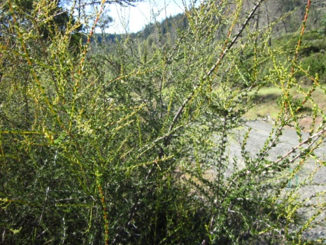
Chamise is one of those plants where the harder the conditions, the more it thrives. It can grow where most other shrubs and trees can’t; on hot, dry, sterile soil. Chamise sprouts heavily after fires. It develops a growth called a root crown gall. The root crown gall is a ball type thing just under the ground, and it sends up the sprouts after a fire. See if you can find one.

COYOTE BRUSH
Baccharis piluaris

This is a common shrub along the coast where it is more often found than in the inland areas. It grows to 4 to 5 feet tall, and the trunk can be up to 3 inches across.
Its leaves are small, evergreen and have serrate margins. It blooms heavily in midsummer. The flowers develop into great quantities of cottony-winged seeds which, is the reason Coyote Brush gets its other name, Fuzzy Wuzzy. These seeds resemble millions of Dandelion tops and they fly everywhere in the wind. This is why after a fire; Coyote Brush can pop up everywhere!

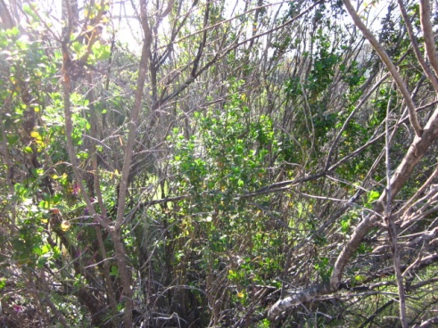

VIEW OF THE PLANT COMMUNITIES
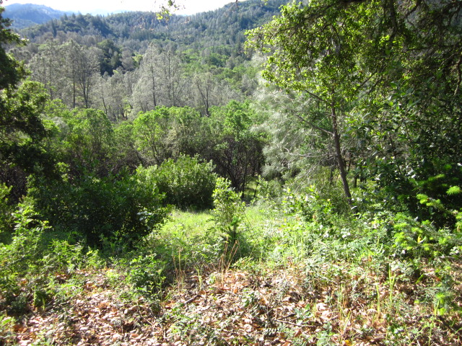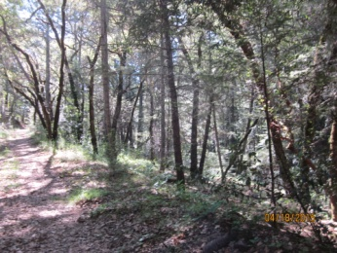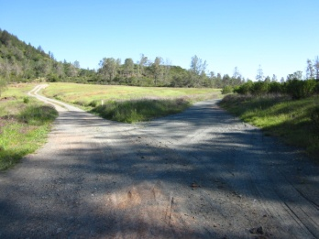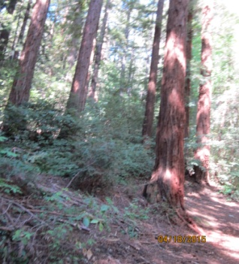A A. Green B. Gray Green C. Yellow Green D. Blue Green

As you look out over the 4-H camp, there is a wide variety of plant communities. The colors of the areas are one indication of the types of plants who live in these communities. Here is a small matching test.
Match the community with its picture
- Chaparral A. Green
- Ball diamond Meadow B. Gray Green
- Metcalf Trail Redwoods C. Yellow Green
- Transition Trail Oaks D. Blue Green

Answers: 1-A, 2-C, 3-D, 4-B

MANZANITA
Arctostophylos starfordiana

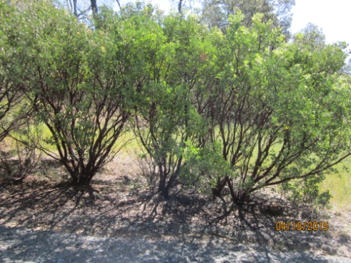
In Napa when chaparral is mentioned, Manzanita is thought of. There are many forms of Manzanita. There are at least 25 different forms of Manzanita in the San Francisco Bay region.
In the chaparral community, Manzanita in its various forms is the predominant plant. It can usually be recognized by its smooth, red bark on stout stems. The leaves are generally small, up to an inch across, leathery and gray to green in color. The flowers are generally dainty white bells. The fruit is a little apple, up to a half inch across, which is nearly 50% seed.

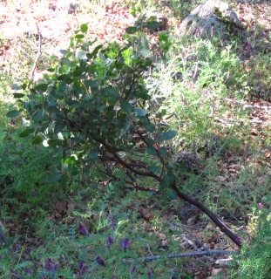

POSION OAK
Rhus diversiloba

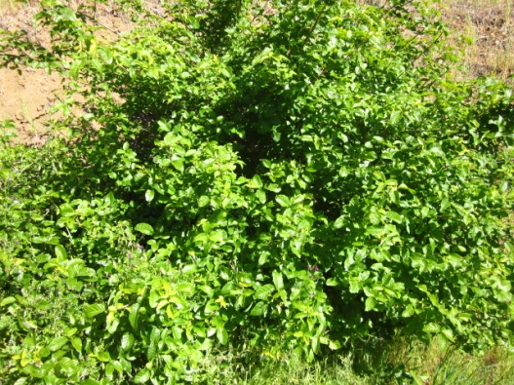
Poison Oak can fool you. Sometimes it looks like a bush, sometimes vine like, and still other times it can almost look like a small tree. It has shiny, bright leaves in the Spring and Fall. Its leaves resemble an oaks, but they are in groups of three. Most people are allergic to the oil which is in the leaves and stems, both can cause a terrible rash. This is a plant you want to remember because it is everywhere in California.
The Indians, for the most part, weren’t allergic to the oil. They used it to make a black dye.

SCRUB OAK
Auercua dumosa
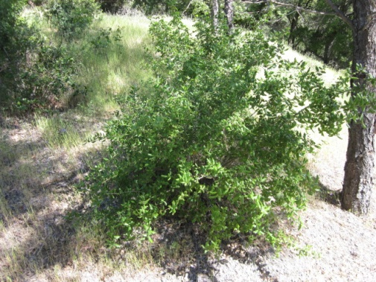
This is a little oak, which very seldom grows to tree size. The leaves are different in sizes, shapes, and are generally gray-green. The bush resembles holly. It grows back well after fires and is good deer food. Notice that it has many oak characteristics. Can you name some of them? Can you find any acorns on this shrub?

THE ANIMALS
This fine dust shows animal tracks clearly. Everytime I’ve been on this trail I’ve found at least two or three different types of animal tracks. How many can you find?
When I thkink of the forest I like to think of areas such as Metcalf. I think of big trees, cool shade, a little creek, ferns and a deer running around. That type of forest is food for some animals but most would starve. The majority of the animals including the deer, need more than that type of forest to survive.
The scrubby, hot, stickery forest you see around you is more important as a food source to wildlife in general. So next time you see these “ugly shrubs” you’ll apprecite it as an important wildlife food source.

QUAIL- walking hopping COYOTE PACIFIC RATTLESNAKE

MOUNTAIN LION MULE DEER

BAY LAUREL and the STRUGGLE FOR SURVIVAL 4 & 9
Umbellularia California

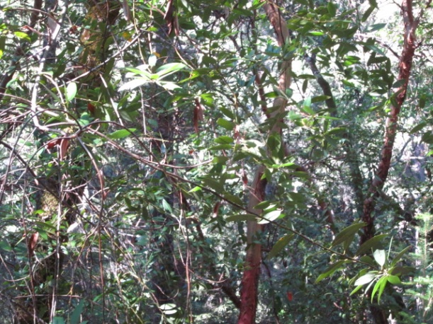
The California Laurel is marked by three characteristics:
- The odor of it’s leaves
- The olive shaped fruit and
- The numerous leaves on a branch.
In the forest, the Bay looks very different; it is much bigger. In this area, it grows almost as a shrub. Growing conditions have a lot to do with how plants grow. On the Transition Trail, the Manzanita grows to 15 or 20 feet tall, (almost a small tree) but there are few of them. On this trail there are many Manzanitas, but all are in bush form. This is due to the available light.
Something to think about is how much light is available in a forest. On Metcalf the redwoods are so tall there is hardly any light so trees have to grow tall just to get some. On this trail all the bushes are short so none have to grow tall to get light. See if you can find other trees that are different in other places.

DIGGER PINE
Pinus sabinian
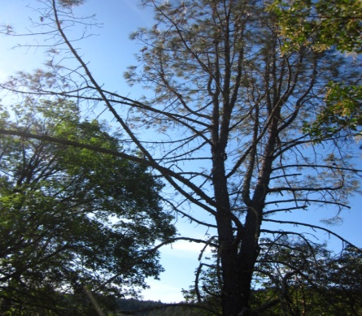
This is the large tree of the dry forest areas. The Digger Pine is a tree that grows in the Transition Trail as well as the chaparral.
This tree can grow to be a hundred feet tall. In the Chaparral area it generally doesn’t grow past 40 feet. The needles are 6 to 12 inches long, gray-green in color and in bundles of three. The Digger looks less like a tree and more like an overgrown shrub. The cones of the tree are heavy and up to 12 inches long. The seeds from the pine cones are hard, but once cracked are nutty tasting. These seeds were popular with the Indians for food.
When I eat Manzanita apples, I put them in my moist mouth and let them sit for 30 seconds. The apples are dull and dry at first, but as the saliva works on the sugars they pick up a subtle sweetness. Don’t swallow the seeds!

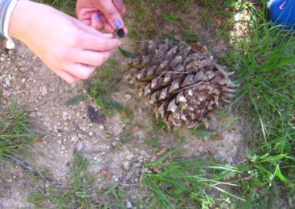

COAST LIVE OAK
Quercus agrifolia

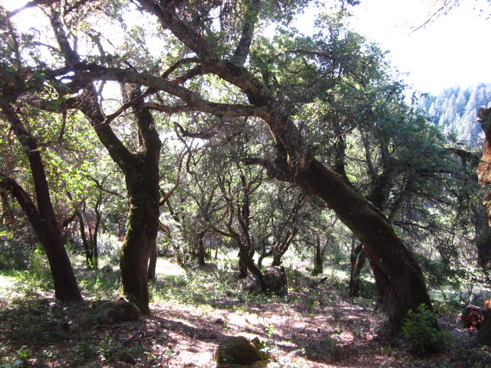
This is the most common tree in the oak regions of Napa. (In this transition forest, it is just one of many types of trees.) Live Oaks have smooth, green-brown bark. Its leaves are teaspoon shaped and size with many jagged teeth. The top of the leaf is dark green while the inside is lighter green. The scorns are approximately one inch long. If you have soft feet, don’t walk under this tree.

BLUE OAK
Quercus douglassii

The Blue Oak is a moderate sized oak tree, under 50 feet tall. Its leaves are blue green with shallow lobes. The acorns are thin and short. It is generally found in warm foothills around California. The main use for this tree is fuel and fence posts.

CALIFORNIA BLACK OAK
Quercus kelloggii

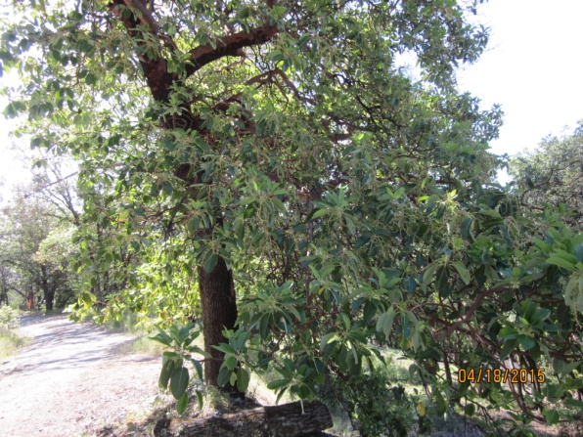
The Black Oak likes to be neighbors with the Ponderosa Pine tree. It too can be a dominant member of some forest communities.
The Black Oak has shiny, dark green, deeply lobed leaves. The tree can grow to 80 feet tall, but in this area they generally don’t reach that height. The acorns were popular with the Indians for making their corn meal flour. The Indians had to leach out the tannin before using the flour.

PONDEROSA PINE
Pinus ponderosa

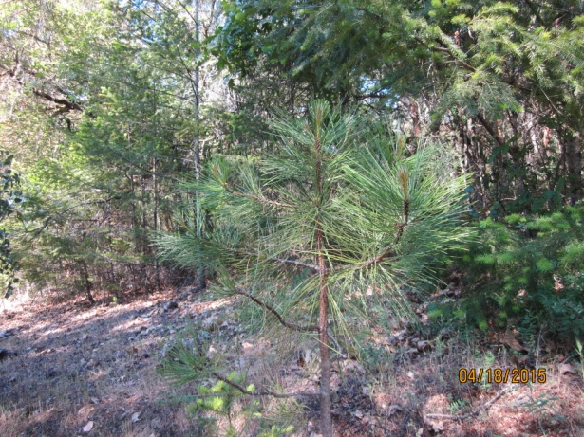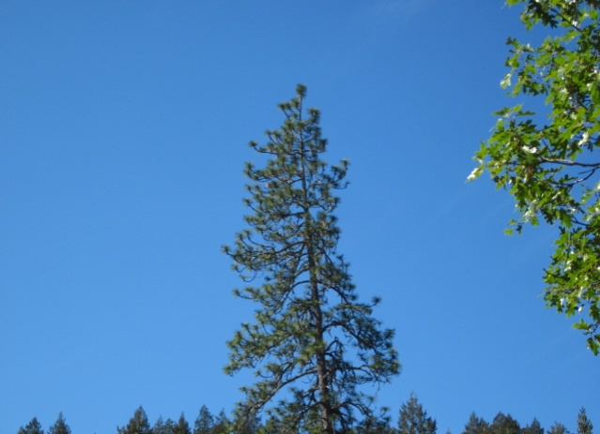
The Ponderosa Pine is the most important timber species in the Sierra Nevada forest belt. The tree can grow to 180 feet tall, by 4 feet in diameter, though there is no tree that big in camp. The leaves are green, in groups of 2 or 3 needles, 4 to 7 inches long. The cones are orange brown and are 3 to 6 inches long. The bark is from yellow-brown to cinnamon-red, and in large flat plates. The Ponderosa Pine is the good looking pine tree around the camp.

OREGON OAK
Quercus garryana

This is a white oak. One of the unique things about this oak is the acorns, which are afatter at the bottom than at the top. This makes them look bloated. The leaves are from 3 to 6 inches long and have rounded lobes. The leaves are also a more true green. The acorns are an important food for the deer in the fall. At Las Posadas, these trees rarely grow taller than 30-35 feet.
Note on Intermixing
You’ve now seen a Black Oak, Blue Oak, and an Oregon Oak. Now there are oak trees around that are similar to these, but aren’t the Black, Blue, or Oregon Oak. These oaks are mixed up. They cross pollinate and make new hybrid oak trees.

MADRONE
Arbutus menziesii
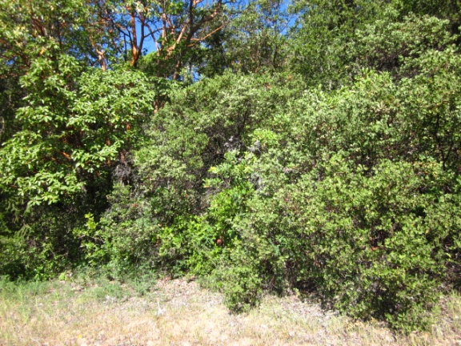
One of the distinctive features of the Madrone tree is its red brown papery bark. Many of the trees in this area are small, between 30-35 feet tall. At different places in the camp, the Madrone trees have grown to nearly 100 feet tall. The leaves of the Madrone are large, at least 3” by 6”. They are dark green on top and light green underneath. It has white flowers and red berries. Madrone trees are one of the first trees to sprout back after a fire. The wood from the Madrone is becoming poplular in flooring and veneer.

EROSION on the HILL

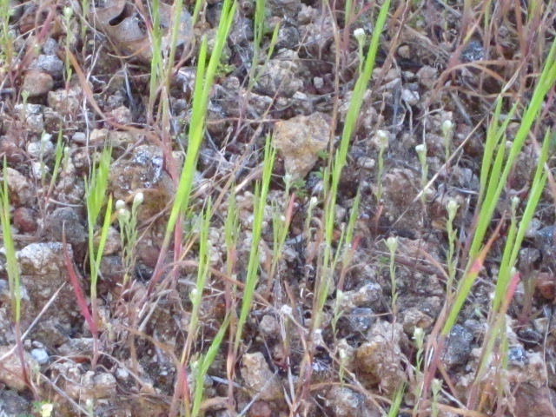
Take a minute to notice the little pillars on the side of the road. These pillars are caused when a rock protects the ground underneath it from washing away. The rain washes away the surrounding dirt, leaving the protecting rock standing on a pillar of dirt. The importance of this is to point out erosion.
Erosion means wearing away. We’ve all seen gulley’s where a raging creek has worn away the ground; that’s erosion. The Grand Canyon is a huge example of erosion. These pillars are an example of a way to protect the ground from washing away.

COAST REDWOOD
Sequoia sempervirens
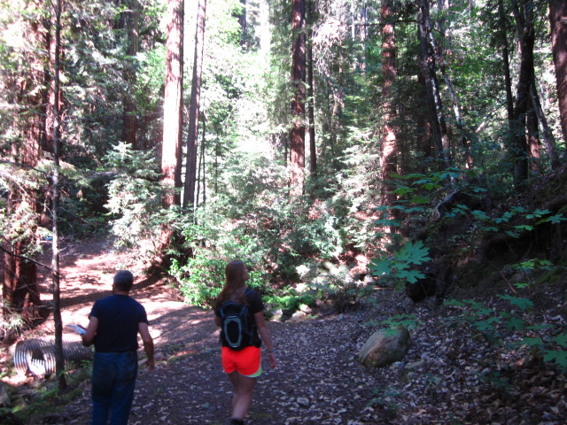
This is the most important tree in this section of the forest. It can grow to be 350 feet tall. Its bark is soft, fiberous and red. Its needles are 1 to 2 inches long and are dark green on top and light green underneath. The cones are 1 to 2 inches long.
Fire is important in the development of Redwoods. The redwood tree bark is hard to burn so fires that kill most other trees may not kill a Redwood. Another way Redwoods work with fire is that when the tree gets cut or burned, many sprouts come out at the base of the tree. This causes a killed Redwood to grow back quickly. When you see a group of Redwoods growing together they are usually sprouts. Redwood is an important wood to build with.

BIG LEAF MAPLE
Acer macrophullum

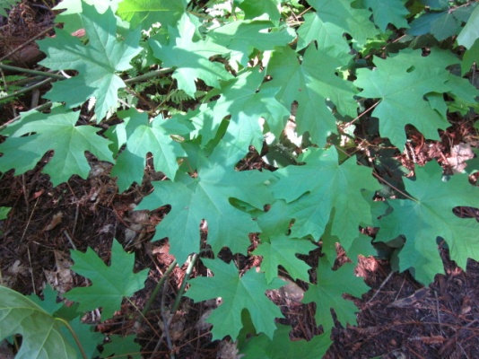
This tree is usually found as the under story with other trees. It can grow from 30 to 100 feet tall. The leaves are large, 4 to 10 inches long, with deep cut lobes. The seeds have wings and are covered with stiff hair. Maple wood is used to make furniture.

TANBARK OAK
Lithocarpus densiflora
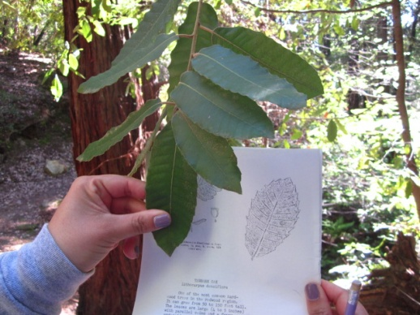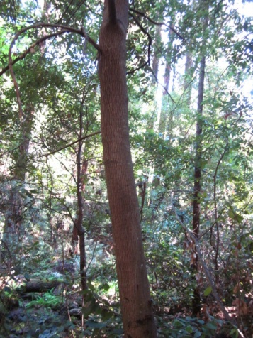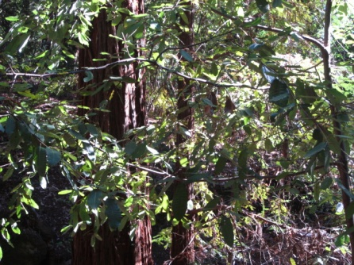
One of the most common hardwood trees in the redwood region is the Tanbark Oak. It can grow from 50 to 150 feet tall. The leaves are large (4 to 5 inches) with parallel veins and a fuzzy underside. The acorns are 2 to 3 inches long and have a frilly cap. When the tree is cut or burned, it sends up clumps of sprouts from the base. The bark from this tree is high in Tannin and was used for tanning leather.
CHAIN FERN
Woodwardia radicans
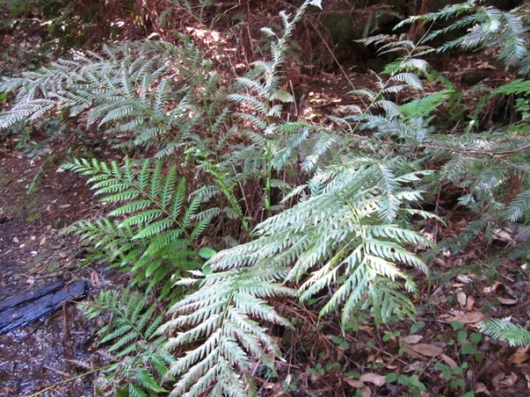
This is a beautiful, lush green fern. It grows in moist locations. It can grow to 5 feet tall.
This creek is the drainage from the camp water supply. There hasn’t always been a creek here. As you look up the creek you can see a whole trail of ferns. You can also see a few dead trees. When this turned from dry ground to a creek, it killed some plants, i.e. Douglas Fir, etc., while making it a good place for other plants to live.

WOOD ROSE
Rosa gymnocarpa
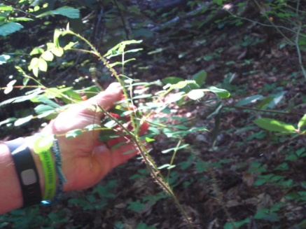
Believe it or not this little plant is a cousin to the blackberry. It grows from 3 to 6 feet tall. It has sticker stem, and white or pink flowers.

CALIFORNIA HAZELNUT
Corylus californica
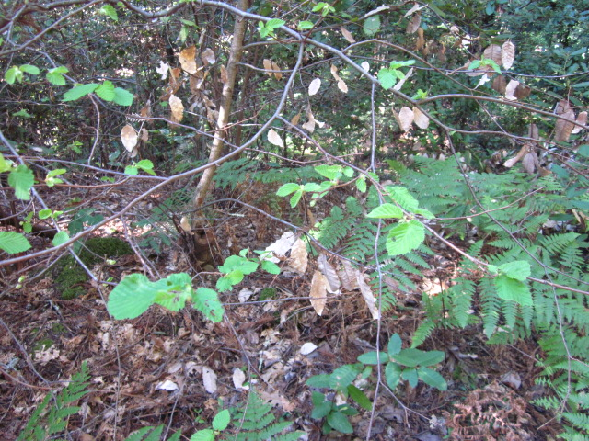
The California Hazelnut is usually a large shrub, but occasionally may reach tree size. It grows mainly in moist wooded canyons. It is recognized by its soft fuzzy leaves. The nuts are very popular with squirrels, so the nuts are very hard to find.
CALIFORNIA GRAPE
Vitis californica
This is a vine that can grow to 60 feet long. It is generally found climbing over trees and shrubs along streams. The small grapes are eaten by birds.

THE TREE RING’S

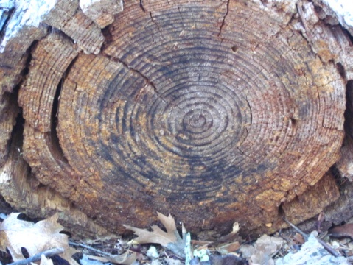
How can you tell how old a tree was when it was cut down? Count the rings. Every ring you count means the tree is another year older. Some Redwood trees can live to be several hundred years old.
CALIFORNIA MAIDEN-HAIR FERN
Adintum jordani
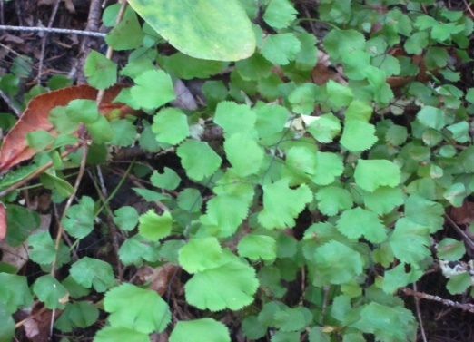
The Maiden-Hair fern is a delicate plant that looks like it should be in a Japanese painting. The stems are very thing and black. The leaves are fan shaped and lacey. It grows in moist, rocky canyons. Indians used this plant for an ointment to soothe inflamed skin.

CALIFORNIA BUCKEYE
Aesculus californica
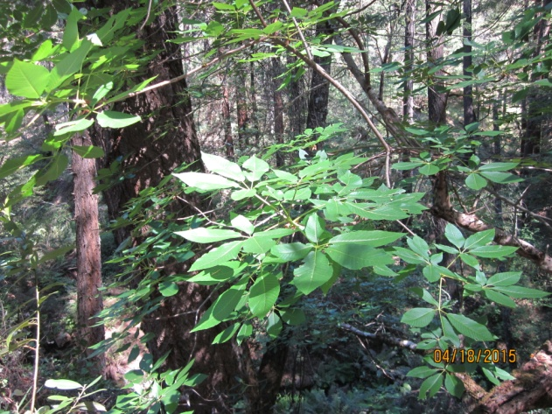
The Buckeye is one of the more spectacular trees in the woods when it blossoms. The flowers are cream colored spikes that make the tree look like a giant candelabra. The nectar from these flowers is poisonous to bees. The leaves are made of five large leaflets, centrally joined. The seeds are bigger than walnut and poison also. The Indians used to eat the seeds after leaching all the poison out.

DOUGLAS FIR
Psuedotsuga menziesii

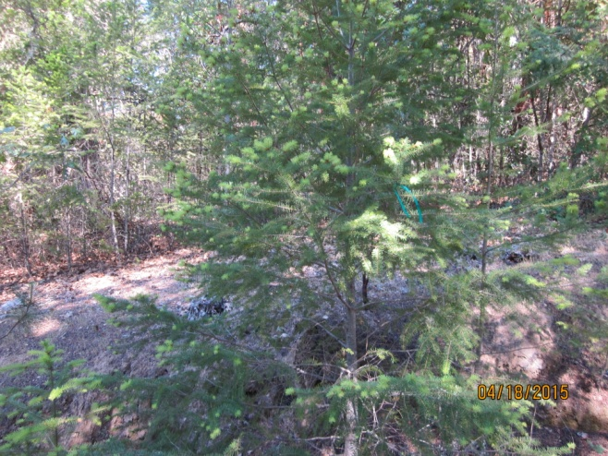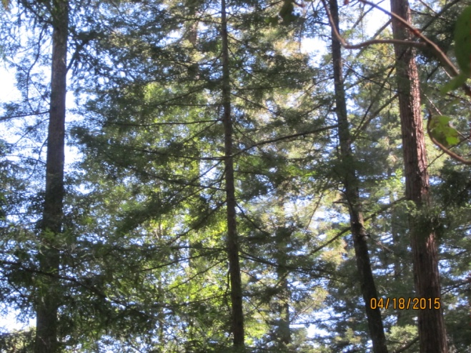
This is one of the biggest trees in this forest. It can be 8 to 10 feet in diameter and 275 to 300 feet tall. This is the most important lumber tree in the west.
Its needles are 1 ½ to 2 inches long, are dark green and soft to touch. The cones are 2 to 3 inches long with scales and little mouse tails sticking out. Douglas Fir is a popular Christmas tree.

FIRE IN THE FOREST
Fire is important to forest areas. There are some trees whose seeds will grow only after being burned. Some trees like the Redwood are able to overshadow all other trees because of its ability to withstand fire. Fire cleans out a forest.
This tree is a good example what fire can do to a strong healthy tree. This tree is deeply scarred. Harvester ants, termites, other insects and diseases attack this scar. The fire of 1932 might not have killed this tree, but it probably shortened its life.
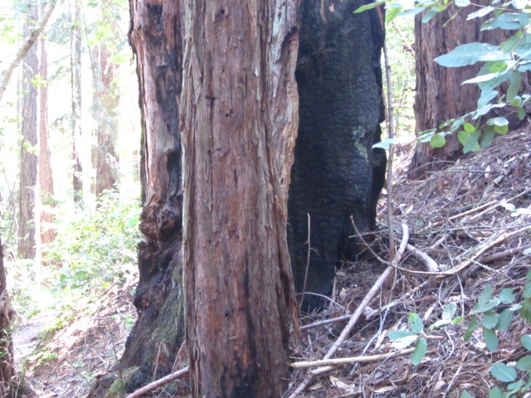

EXPLORING
NATURE
AT
LAS POSADAS 4-H CAMP

Prepared by:
Las Posadas 4-H Camp
Hiking Short Course
May 2015

